# A PROJECT ON

**Faculty Attendance System**

Submitted in partial fulfillment of the requirements for the Award of Degree of

Bachelor of Computer Application

**2012-2015**

**Submitted by: Under the Guidance of:**

**Rohit Sharma Mr. Manpreet Singh**

**Pawan Kumar**



**BHARATI VIDYAPEETH DEEMED UNIVERSITY, PUNE (INDIA)**  
School of Distance Education (SDE)  
Academic Study Center : BVIMR, New Delhi  
(University established under 3 of the UGC act,1956)

|  |  |
| --- | --- |
|  |  |

# Student Undertaking

This is to certify that “**Rohit Sharma” and “Pawan Kumar”** had completed the Project on “**Faculty Attendance System**” under the guidance of “**Mr. Manpreet Singh”** in the partial fulfillment of the requirement for the award of degree of **Bachelor of Computer Applications** of BVU**, SDE, Academic Study Center BVIMR, New Delhi**.   This is an original piece of work & I have neither copied and nor submitted it earlier elsewhere.

**Students Name and Signature:**

**Course:**

**Acknowledgement**

We deem it a time bound privilege and function to dedicate this page of mine to a number of helping hands for their cooperation & guidance that enabled Us to dedicate time and effort in framing Our analysis into a conceivable system.

Our most sincere thanks to the following persons who have given their valuable time in helping me go about my project.

We wish to thank **Dr. Vikas Nath**, the director of B.V.I.M.R for their constant support.

We wish to thank **Mr. Manpreet Singh** for his guidance and encouragement, and the staff of BVIMR.

Above all we wish to thank Our parents for their constant and wholehearted support through the project.

Name  & Signature of the Student

**CONTENT**

**CHAPTER 1**

**INTRODUCTION**

1.1      Introduction   
1.2      Introduction about Project  
1.3      Present state of the art  
1.4      Need of Computerization of System  
1.5      Proposed Software (What would s/w accomplish)  
1.6      Importance of the Work

**CHAPTER 2**

**SYSTEM ANALYSIS**

2.1      Feasibility Study of Project includes its types

2.2      Analysis Methodology (Types)

2.3      Choice of Platforms s/w & h/w

2.3.1   Software used

2.3.2   Hardware used

**CHAPTER 3**

**SYSTEM DESIGN**

3.1 Design methodology        3.2 Menu flow diagram 3.3 Data flow diagram  
3.4      Screen Design with coding          

**CHAPTER 4**

**TESTING AND IMPLEMENTATION**

4.1 Testing Methodology (Types)

4.2 Unit Testing

4.3 Module Testing

4.4 System Testing

4.5 Alpha/Beta Testing

4.6 White Box Black Box Testing

4.7 Implementation

4.8 Post Implementation

**CHAPTER 5**

**CONCLUSION AND REFERENCES**

5.1      Conclusion

5.2    Limitation of System

5.3 Future scope of modification

5.4 H/W Requirement

5.4.2   S/W Requirement

**CHAPTER 1**

**1.1 Introduction**

This project has been designed with keeping in mind the concept of marking attendance through a simplified and sophisticated manner of different faculties of an organization which will ultimately help the faculty members of that particular organization to manage their attendance of a particular interval of time i.e. a week or a month or an year.

# 1.2 Introduction about Project

This project is developed with an aim that the faculty members of any organization would be able to manage their regular attendance in a very systematic manner through this software which is a very feasible one in all the aspects.

While making this project, the security issue was kept in mind due to which this project is very proficient as far as security is concerned. This project prompts for a password while dealing with delicate information like saving the attendance which makes it very powerful regarding the security issues.

The whole project is divided in some menus and among those, few are divided in sub-menus. The menus include Login menu, Help menu, About Us menu, Exit menu, Sign up menu, etc.

In Login menu, there are two submenus namely Admin login and Faculty login out of which, faculties are required to use the Faculty login menu in order to make any changes in their attendance. Here, a list containing names of all the faculties whose accounts are there on this project, is available and from there, the user can select his/her name. Then there is a button to add the username of the faculty automatically to the box reserved to enter the username manually. This will surely save time and effort of the user that could have been wasted in writing the name manually. Finally, by entering the correct password, the user will be able to gain access of the project by doing any changes in their attendance.

The Admin login panel is for the admin purpose. It is designed with high security keeping in mind the security reasons of admin usage and the various actions that are to be handled by the admin like managing the users and their details. These users are obviously the faculty members only. When the menu “Admin Panel” is clicked, then it will prompt the user to type the answer of the security question which was set during the design of this software. If the entered answer matches the desired answer, then only the user will be allowed to enter the admin login panel otherwise not. In case, the user entered the correct answer then the admin panel will open. Now, to add an extra security for the admin use, there is the need to login again in the admin panel here by typing the correct username and password at this particular stage. Now, only and only if the username and password are correct, then a button will appear on the screen and by clicking that button, the user will be able to reach the control panel of admin otherwise, he/she not be allowed to enter the admin control panel.

In Help menu, everything regarding the functioning of the project is being given i.e. how to use this software and enjoy its benefits. By clicking this menu, a form will appear containing all the necessary for operating this project.

In Sign Up menu, a faculty which is using the software for the first time, will be able to make his/her account on this project and can gain access to the login into the project by logging in again by the username and password which he/she has just typed while signing up.

In About Us menu, a form will be shown containing a brief details like contact number, email-id, etc. of the us of the project i.e. Rohit Shama and Pawan Kumar are given.

In Feedback menu, a new form will appear which will contain one empty box and two buttons. In the first box, the user can put any comment or its his/her wish to give any comment in the box. Then there will be another box in which the faculty will have to type his/her email-id. After that, the faculty would be having two choices whether to submit the feedback or not. If the button “Submit” is clicked, then the email-id and the feedback of the particular faculty will be stored and in case the button “Don’t Submit” is clicked, then nothing will be stored.

# 1.3 Present state of the art

# As far as attendance systems that are available in the market nowadays are concerned, they all have special types of devices like touch screen, voice recognition system, etc. which are helpful to perform some magical operations like identify the touch of a person’s hand, recognize a person’s voice etc. which makes them very effective to use. Nowadays, almost every organization has computerized the attendance. But alongwith these merits, these attendance systems have a financial demerit too i.e. these attendance systems are a bit costlier.

# This problem is solved using this project as it is available free of cost on the internet. Although, it will not be so much advanced like the other automatic softwares but yet it is very much effective and works like the advanced and automated softwares available in the market.

# 1.4 Proposed Software (What would s/w accomplish)

The proposed solution of the problem is to putting an advanced project which will have functionalities the existing project does not hold. The problem was also in getting the similar, relevant and consisting images related to the organization. For this purpose new images were developed using Photoshop.

The methodology used for this project was **Prototyping Model**.

Software prototyping, an activity during certain software development, is the creation of prototypes, i.e., incomplete versions of the software program being developed.

A prototype typically simulates only a few aspects of the features of the eventual program, and may be completely different from the eventual implementation. The conventional purpose of a prototype is to allow users of the software to evaluate developers' proposals for the design of the eventual product by actually trying them out, rather than having to interpret and evaluate the design based on descriptions.

Prototyping can also be used by end users to describe and prove requirements that developers have not considered, so "controlling the prototype" can be a key factor in the commercial relationship between solution providers and their clients.

Firstly the Requirements of the client were discussed, which led to the rough design development of the web site. In this rough design some rough layouts were designed and conversed with the clients.

The clients then decided the best suited format for their web site. After this step the next step was to use tools and design with colors and other text related tools.

This step was taken in various periodic shuffling between the client and the designers where timely inputs were taken from the client. As when the client asked for certain changes they were made.

Finally after various shuttling the product so developed was the final layout of the project which was then tested using black box technique and ready to be published.

Feasibility Study

System Analysis

Requirement Analysis

Implementation

Testing

Testing

Design & Coding

# 

# ****CHAPTER 2****

# 2.1      Feasibility Study of the Project

The basic purpose of feasibility study or survey is to determine whether the whole process of system analysis.

Computerization would be worth the effort for the organization..

Feasibility study asks whether the managements’ concept of their desired new system is actually an achievable, realistic goal, in terms of money, time and end result difference to the original system. Often, it may be decided to simply update an existing system, rather than to completely replace one.

The feasibility study results in the preparation of a report called the Feasibility Study/ Survey Report, which is submitted to the management for consideration. It contains the following details:

A proposed solution to the problem

Rough estimate on the cost/benefits analysis if the solution is implemented

Approximate time, effort and cost estimates for completion of the project

# TYPES OF FEASIBILTY STUDY:-

Economical Feasibility

Technical Feasibility

Operational Feasibility

Behavioral Feasibility

# ECONOMICAL FEASIBILITY

Economical analysis is the most frequently used method for evaluating the effectiveness of the new project most commonly known as cost/benefit analysis. It is the procedure to determine the benefits and savings that are expected from the new project and compare them with costs. If benefits overweigh costs, then the decision is made to design and implement the new project. Otherwise, further justification or alternations in the proposed system will have to be made if it is to have a change of being approved.

In developing cost estimates for the project, we need to consider several cost elements. Among them are:-

**Hardware Costs:-** relate to the actual purchase or lease of the computer and peripherals like printer, disk drive, tape unit etc.

**Facility Costs:-** or one time costs are expenses incurred in the preparation of the physical project where the application or the computer will be in operation.

**Supply Costs:-** are available costs that increase with the increased use of paper, and the like.

# TECHNICAL FEASIBILITY

It is related to the software and equipment specified in design for implementing the new system. It confirms that the necessary technology .i.e. required for the proposed system exists in the organization. The issues involved are:-

**Matching the configuration requirements:** Checking if the suggested solution will be supported by the existing technology, whether it is capable of sorting the volumes of data and meeting the further requirements related to the H/w and S/w.

**Making the project secure:** The project should be secure enough so that no one can make use the information of the organization in a wrong or negative manner.

# OPERATIONAL FEASIBILITY

It is mainly related to human organizational and political aspects. Not only must an application make economic and technical sense, it must also make operational sense. The basic question that you are trying to answer is, “it is possible to maintain and support this application once it is in production?”

Building an application is decidedly different than operating it, therefore you need to determine whether or not you can effectively operate and support it.

With the new project, there will be no job-cutting process will be done. Rather, the organization is expecting that through the new project more and more people become aware of it and hence new applicants for various job profiles will approach. The new project will at some amount reduce paper work they have to do everyday. The task distribution will remain the same.

There will not be a need of making all the staff members to teach a certain new skill to work on the new project as working on the world wide web is a kids play now a days.

# BEHAVIOURIAL FEASIBILITY

The project is behaviorally feasible. People are inherently resistant to change and computers are known to facilitate changes. An estimate should be made on how strong reaction the user staff is likely to have towards the development. The system is mainly of use of the staff who will make necessary changes and updated as and when required and the people who will access the World Wide Web.

**Details:**

There was an internal survey and analysis is done regarding how the latter thinks about the new project proposal and to this the response was in the favor of the proposal.

# 2.2      Analysis Methodology (Types)

System analysis is the most important phase in a system development. In this phase, the new project to be prepared is fully analyzed in all aspects. Analysis is actually a detailed study of the various operations performed by a system and their relationships within and outside the system.

A key question is: what must be done to solve the problem?One aspect of analysis is defining the boundaries of the system and determining whether or not the project should consider other related systems.

During analysis, data are collected on the available files, decision points handled by the present project. Some logical system models and tools that are used in analysis (Data flow diagrams, interviews) are commonly used tools in analysis. It requires special skills and sensitivity to the subjects being interviewed. Bias in data collection and interpretations can be a problem. Training, experience and common sense are required for collection of the information needed to the analysis.

Once analysis is completed, the analyst has a firm understanding of what is to be done the next step is to decide how the problem might be solved. Thus, in a system design we move from the logical to the physical aspects of the life cycle.

# 2.3.1 Software used

# Operating System : Windows 7

# Front End : Microsoft Visual Basic 6.0

# Back End : Microsoft Access 2007

# 2.3.2   H/W REQUIREMENT

The hardware requirements needed to run this system both server and client configurations are as follows

Processor : Intel® core™ i3-2350m cpu@2.30GHz

RAM : 2GB

Hard Disk : 340 GB

Printer : Laser Printer

**CHAPTER 3**

# 3.1      DESIGN METHODOLOGY

The term ‘design’ describes a final system, and the process by which it is developed. It refers to the technical specifications (like blueprints) that will be applied in implementing the project. Hence, it signifies how the project will meet the requirements which were specified during system analysis.

Design is a creative process requiring insight and flair on the part of the designer. It must be practiced and learnt by experience and study of existing systems.

Any design problem must be tackled in three stages:

* Study and understand the problem
* Identify gross features of at least one possible solution
* Describe each abstraction used in the solution

**The progression from an informal to a detailed design**

Informal design outline

Informal design

More formal design

**Finished Design**

Figure 3.1

A good project design engages visitors, makes it easy for them to navigate and compels them to explore further. Attractive graphics that support the company’s message are important. But large graphics that take a long time to load frustrate users. Many visitors won’t wait long enough for the graphic to finish loading. Additionally, visitors are less likely to return to a site that has cumbersome or confusing navigation.

**User interface:** The user interface is the first and last element observed by a project visitor. User interaction design begins with the visual presentation best suited to delivering on user expectations. It then continues on to focus on the physical ways in which a user interacts with the site content. Good graphic design acts to **increase the communicative value** of the interface, which leads to increased user satisfaction. In test after test, it has been proven that the simplest projects are the most effective in service environment - graphics should have a purpose, navigation easy and intuitive, and the interface uncluttered.

**3.2     Menu Flow Diagram**

**Project**

**Login**

**Signup**

**About Us**

**Exit**

**Help**

**Feedback**

# 3.3   Data Flow Diagram

**Context Level DFD :**

Opens

User

Faculty Attendance System

# First Level DFD

Visit

User

# 

EXIT

HELP

FEEDBACK

LOGIN

SIGN UP

ABOUT US

# 3.5      Screen Design with Coding

**HOME**

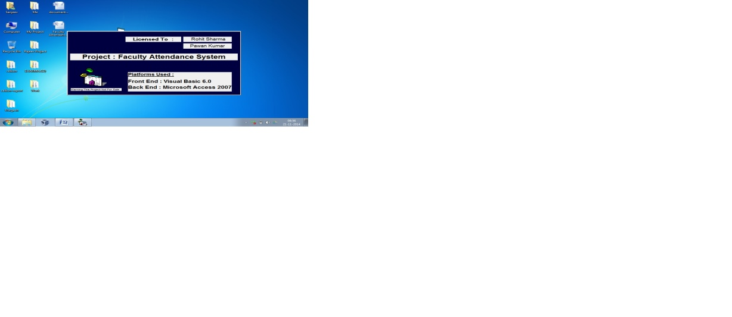

**FACILITIES**

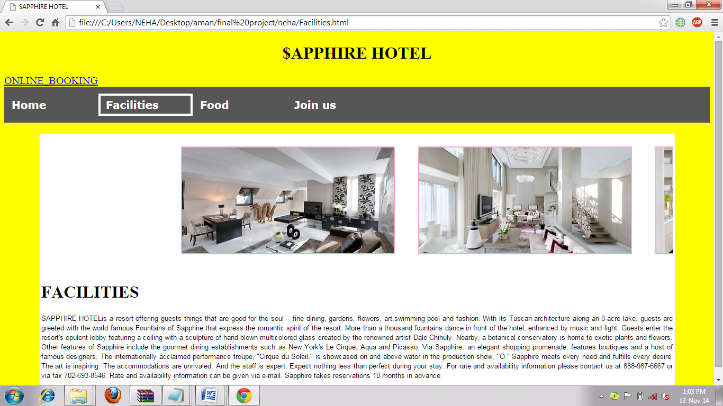

**FOOD**

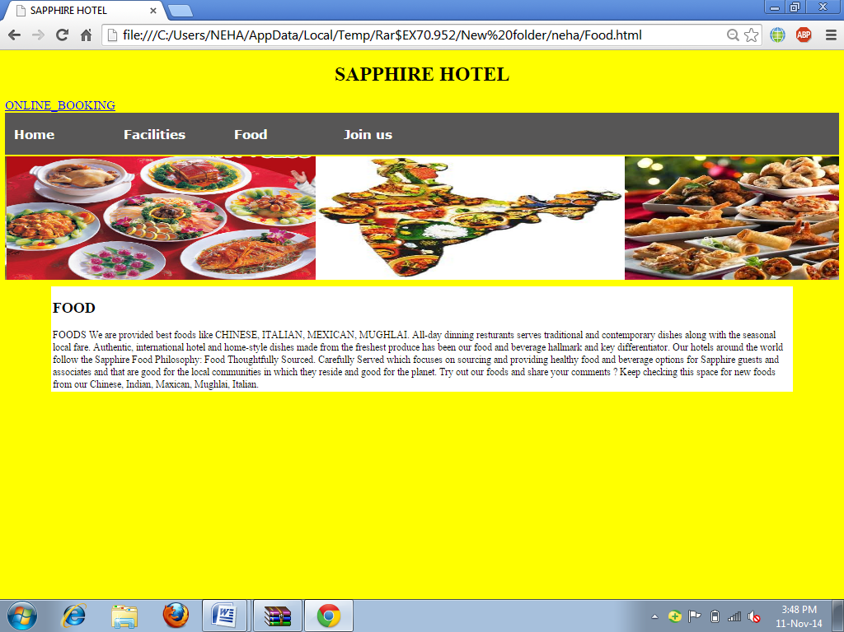

**JOIN US**

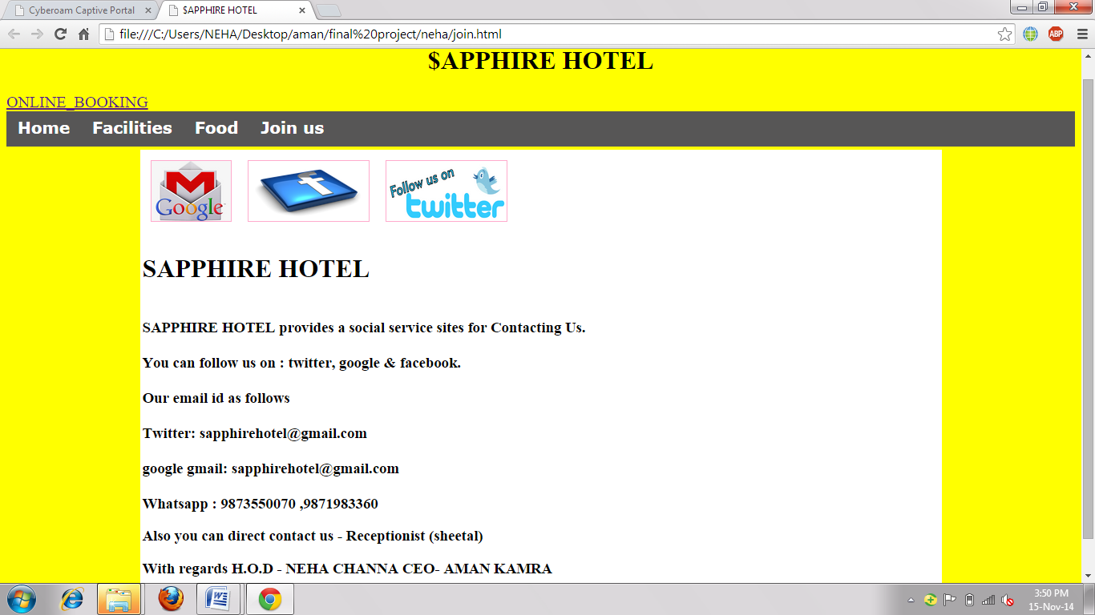

**ONLINE BOOKING**

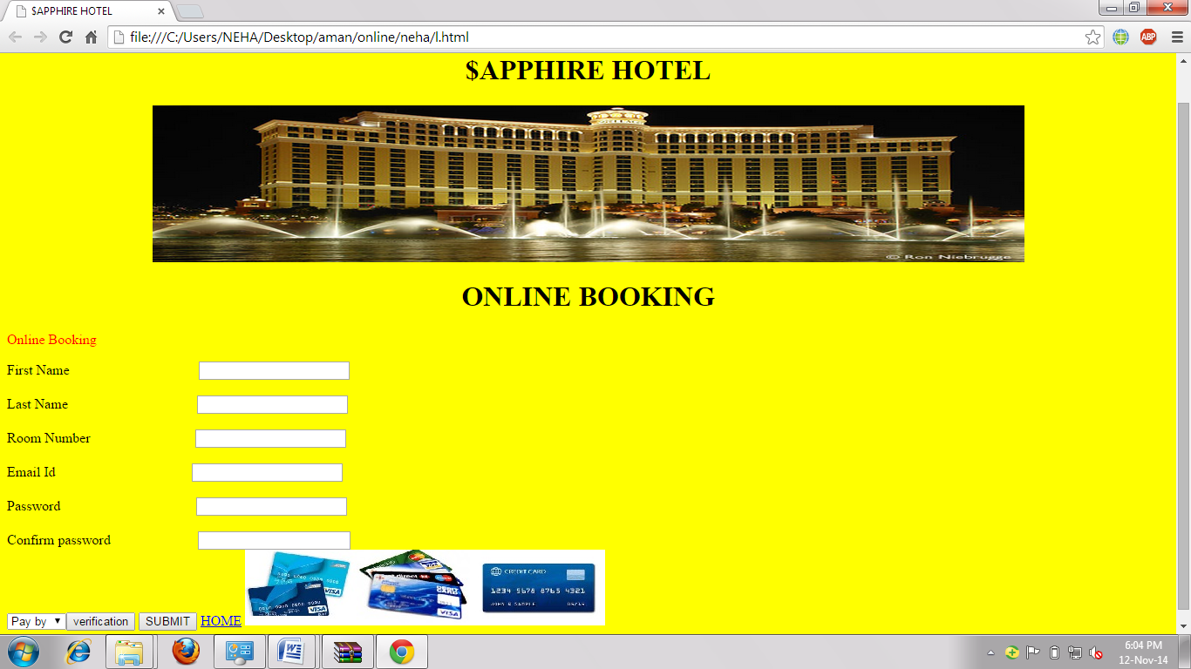

**Thanks page**

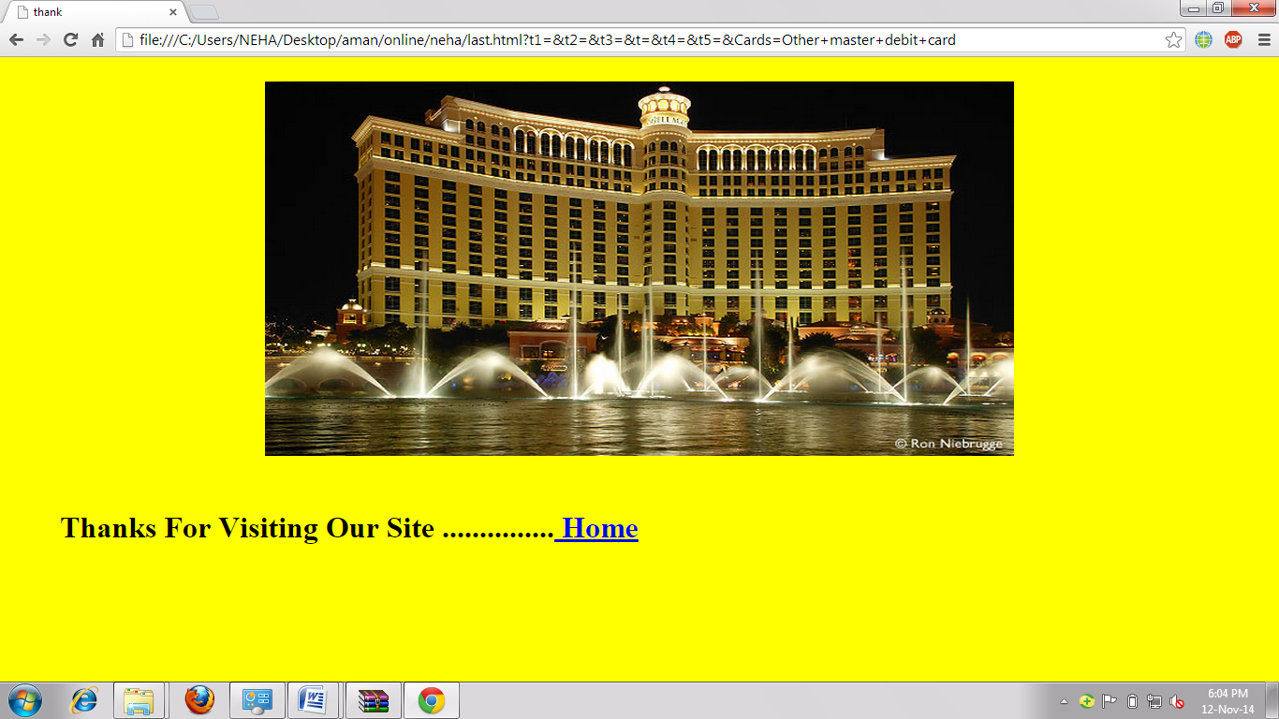

**CODING OF FORMS:**

**SPLASH SCREEN 1**

Private Sub Timer1_Timer()

Unload Me

frmSplash1.Show

End Sub

**SPLASH SCREEN 2**

Private Sub Timer1_Timer()

Shape1.Visible = False

End Sub

Private Sub Timer2_Timer()

Shape2.Visible = False

End Sub

Private Sub Timer3_Timer()

Shape3.Visible = False

Form1.Show

Unload Me

End Sub

**FORM 1**

Private Sub mnuAboutUs_Click()

Form7.Show

End Sub

Private Sub mnuAdmin_Click()

Dim a As String

a = InputBox("What is the name of your favourite place", "Please Answer The Security Question To Enter Admin Panel")

If StrComp("hell", a) = 0 Then

MsgBox "Right Answer . Welcome To The Admin Panel", , "Congratulations"

Form2.Show

Else: MsgBox "Sorry! Wrong Answer.You Can't Enter The Admin Panel This Way"

End If

End Sub

Private Sub mnuExit_Click()

If (MsgBox("Are You Sure You Want To Exit The Project ? ", vbYesNo, "Exit") = vbYes) Then

End

End If

End Sub

Private Sub mnuFacultyLogin_Click()

Form3.Show

End Sub

Private Sub mnuFeedBack_Click()

Form6.Show

End Sub

Private Sub mnuHelp_Click()

Form9.Show

End Sub

Private Sub mnuSignUp_Click()

Form5.Show

End Sub

**FORM 2**

Private Sub Command1_Click()

Dim a As String

Dim b As String

a = Text1.Text

b = Text2.Text

If StrComp("rohit", a) = 0 And StrComp("sharma", b) = 0 Then

MsgBox "Login Successful", , "Congratulations"

Command2.Visible = True

Else: MsgBox "Invalid Username/Password", , "Sorry"

Unload Me

End If

End Sub

Private Sub Command2_Click()

Form4.Show

Unload Me

End Sub

Private Sub Form_Activate()

Command2.Visible = False

End Sub

**FORM 3**

Dim X As String, Y As String

Private Sub Command3_Click()

If Combo2.ListIndex = 0 Then

Text3.Text = "manpreet singh"

ElseIf Combo2.ListIndex = 1 Then

Text3.Text = "ashutosh gaur"

ElseIf Combo2.ListIndex = 2 Then

Text3.Text = "santanoo patnaik"

ElseIf Combo2.ListIndex = 3 Then

Text3.Text = "surender singh"

ElseIf Combo2.ListIndex = 4 Then

Text3.Text = "megha sehgal"

ElseIf Combo2.ListIndex = 5 Then

Text3.Text = "himani bhatia"

End If

End Sub

Private Sub Command4_Click()

X = Text3.Text

Y = Text4.Text

Adodc2.CommandType = adCmdText

Adodc2.RecordSource = "select count(*) from login where fname = '" & Text3.Text & "' and fpass='" & Text4.Text & " ' "

Adodc2.Refresh

If Adodc2.Recordset(0) > 0 Then

MsgBox "Login Successful", , "Congratulations"

If StrComp("manpreet singh", X) = 0 And StrComp("manp", Y) = 0 Then

Form8.Show

Unload Me

ElseIf StrComp("ashutosh gaur", X) = 0 And StrComp("ashu", Y) = 0 Then

Form10.Show

Unload Me

ElseIf StrComp("santanoo patnaik", X) = 0 And StrComp("sant", Y) = 0 Then

Form11.Show

Unload Me

ElseIf StrComp("surender singh", X) = 0 And StrComp("sure", Y) = 0 Then

Form12.Show

Unload Me

ElseIf StrComp("megha sehgal", X) = 0 And StrComp("megh", Y) = 0 Then

Form13.Show

Unload Me

ElseIf StrComp("himani bhatia", X) = 0 And StrComp("hima", Y) = 0 Then

Form14.Show

Unload Me

End If

Else: MsgBox "Invalid Username/Password", , "Invalid"

Unload Me

End If

End Sub

Private Sub Form_Activate()

Label1.Caption = Now

End Sub

Private Sub Form_Load()

Adodc2.Recordset.MoveFirst

While Not Adodc2.Recordset.EOF = True

Combo2.AddItem Adodc2.Recordset(0)

Adodc2.Recordset.MoveNext

Wend

End Sub

**FORM 4**

Private Sub Form_Activate()

DataGrid1.Visible = False

DataGrid2.Visible = False

End Sub

Private Sub mnuAllUsersandTheirPasswords_Click()

DataGrid1.Visible = True

End Sub

Private Sub mnuAshutoshGaur_Click()

DataReport2.Show

End Sub

Private Sub mnuFeedbacks_Click()

DataGrid2.Visible = True

End Sub

Private Sub mnuHimaniBhatia_Click()

DataReport6.Show

End Sub

Private Sub mnuManpreetSingh_Click()

DataReport1.Show

End Sub

Private Sub mnuMeghaSehgal_Click()

DataReport5.Show

End Sub

Private Sub mnusantanooPatnaik_Click()

DataReport3.Show

End Sub

Private Sub mnuSurenderSingh_Click()

DataReport4.Show

End Sub

**FORM 5**

Dim a As String, b As String

Private Sub Command1_Click()

Adodc1.Recordset.AddNew

Text1.Enabled = True

Text2.Enabled = True

a = Text1.Text

b = Text2.Text

End Sub

Private Sub Command2_Click()

If Len(Trim(Text1.Text)) > 0 And Len(Trim(Text2.Text)) > 0 Then

Adodc1.Recordset.Update

MsgBox "New Record Added Successfully", , "Added"

Form1.Show

Else: MsgBox "You Have Entered Invalid Username/Password", , "Sorry"

End If

Unload Me

End Sub

Private Sub Form_Activate()

Text1.Enabled = False

Text2.Enabled = False

End Sub

Private Sub Text1_Change()

Command2.Enabled = (Len(Trim(Text1.Text)) > 0)

End Sub

Private Sub Text2_Change()

Command2.Enabled = (Len(Trim(Text2.Text)) > 0)

End Sub

**FORM 6**

Private Sub Command1_Click()

con.ConnectionString = "provider=microsoft.jet.oledb.4.0;data source=C:\Users\Lucky\Desktop\My Project\faculty.mdb"

con.Open

con.Execute "insert into feedback values(' " & Text1.Text & " ' , ' " & Text2.Text & " ' ) "

con.Close

MsgBox "Your Feedback is Stored Successfully.You Will Be Reverted Back As Soon As Possible.Thank You.", , "Thank You"

Form1.Show

Unload Me

End Sub

Private Sub Command2_Click()

Form1.Show

Unload Me

End Sub

**FORM 7**

Private Sub Command1_Click()

Form1.Show

Unload Me

End Sub

Private Sub Command2_Click()

If (MsgBox("Are You Sure You Want To Exit The Project ? ", vbYesNo, "Exit") = vbYes) Then

End

End If

End Sub

**FORM 8**

Private Sub Command1_Click()

If Option1.Value = True Then

con.ConnectionString = "provider=microsoft.jet.oledb.4.0;data source=C:\Users\Lucky\Desktop\My Project\faculty.mdb"

con.Open

con.Execute "insert into attendance values(' " & DTPicker1.Value & " ','Present')"

con.Close

MsgBox "You Have Been Successfully Marked As Present For The Specified Date.", , "Thank You"

MsgBox "Your Attendance is Saved Successfully.", , "Attendance Saved"

DTPicker1.Enabled = False

Option1.Enabled = False

Option2.Enabled = False

ElseIf Option2.Value = True Then

con.ConnectionString = "provider=microsoft.jet.oledb.4.0;data source=C:\Users\Lucky\Desktop\My Project\faculty.mdb"

con.Open

con.Execute "insert into attendance values(' " & DTPicker1.Value & " ','Absent')"

con.Close

MsgBox "You Have Been Successfully Marked As Absent For The Specified Date.", , "Thank You"

MsgBox "Your Attendance is Saved Successfully.", , "Attendance Saved"

DTPicker1.Enabled = False

Option1.Enabled = False

Option2.Enabled = False

End If

End Sub

Private Sub Command2_Click()

DataReport1.Show

End Sub

Private Sub Command3_Click()

MsgBox "Successfully Logged Out.", , "Logged Out"

Form1.Show

Unload Me

End Sub

**FORM 9**

Private Sub Command1_Click()

Form1.Show

Unload Me

End Sub

**FORM 10**

Private Sub Command1_Click()

If Option1.Value = True Then

con.ConnectionString = "provider=microsoft.jet.oledb.4.0;data source=C:\Users\Lucky\Desktop\My Project\faculty.mdb"

con.Open

con.Execute "insert into agattendance values(' " & DTPicker1.Value & " ','Present')"

con.Close

MsgBox "You Have Been Successfully Marked As Present For The Specified Date.", , "Thank You"

MsgBox "Your Attendance is Saved Successfully.", , "Attendance Saved"

DTPicker1.Enabled = False

Option1.Enabled = False

Option2.Enabled = False

ElseIf Option2.Value = True Then

con.ConnectionString = "provider=microsoft.jet.oledb.4.0;data source=C:\Users\Lucky\Desktop\My Project\faculty.mdb"

con.Open

con.Execute "insert into agattendance values(' " & DTPicker1.Value & " ','Absent')"

con.Close

MsgBox "You Have Been Successfully Marked As Absent For The Specified Date.", , "Thank You"

MsgBox "Your Attendance is Saved Successfully.", , "Attendance Saved"

DTPicker1.Enabled = False

Option1.Enabled = False

Option2.Enabled = False

End If

End Sub

Private Sub Command2_Click()

DataReport2.Show

End Sub

Private Sub Command3_Click()

MsgBox "Successfully Logged Out.", , "Logged Out"

Form1.Show

Unload Me

End Sub

**FORM 11**

Private Sub Command1_Click()

If Option1.Value = True Then

con.ConnectionString = "provider=microsoft.jet.oledb.4.0;data source=C:\Users\Lucky\Desktop\My Project\faculty.mdb"

con.Open

con.Execute "insert into spattendance values(' " & DTPicker1.Value & " ','Present')"

con.Close

MsgBox "You Have Been Successfully Marked As Present For The Specified Date.", , "Thank You"

MsgBox "Your Attendance is Saved Successfully.", , "Attendance Saved"

DTPicker1.Enabled = False

Option1.Enabled = False

Option2.Enabled = False

ElseIf Option2.Value = True Then

con.ConnectionString = "provider=microsoft.jet.oledb.4.0;data source=C:\Users\Lucky\Desktop\My Project\faculty.mdb"

con.Open

con.Execute "insert into spattendance values(' " & DTPicker1.Value & " ','Absent')"

con.Close

MsgBox "You Have Been Successfully Marked As Absent For The Specified Date.", , "Thank You"

MsgBox "Your Attendance is Saved Successfully.", , "Attendance Saved"

DTPicker1.Enabled = False

Option1.Enabled = False

Option2.Enabled = False

End If

End Sub

Private Sub Command2_Click()

DataReport3.Show

End Sub

Private Sub Command3_Click()

MsgBox "Successfully Logged Out.", , "Logged Out"

Form1.Show

Unload Me

End Sub

**FORM 12**

Private Sub Command1_Click()

If Option1.Value = True Then

con.ConnectionString = "provider=microsoft.jet.oledb.4.0;data source=C:\Users\Lucky\Desktop\My Project\faculty.mdb"

con.Open

con.Execute "insert into ssattendance values(' " & DTPicker1.Value & " ','Present')"

con.Close

MsgBox "You Have Been Successfully Marked As Present For The Specified Date.", , "Thank You"

MsgBox "Your Attendance is Saved Successfully.", , "Attendance Saved"

DTPicker1.Enabled = False

Option1.Enabled = False

Option2.Enabled = False

ElseIf Option2.Value = True Then

con.ConnectionString = "provider=microsoft.jet.oledb.4.0;data source=C:\Users\Lucky\Desktop\My Project\faculty.mdb"

con.Open

con.Execute "insert into ssattendance values(' " & DTPicker1.Value & " ','Absent')"

con.Close

MsgBox "You Have Been Successfully Marked As Absent For The Specified Date.", , "Thank You"

MsgBox "Your Attendance is Saved Successfully.", , "Attendance Saved"

DTPicker1.Enabled = False

Option1.Enabled = False

Option2.Enabled = False

End If

End Sub

Private Sub Command2_Click()

DataReport4.Show

End Sub

Private Sub Command3_Click()

MsgBox "Successfully Logged Out.", , "Logged Out"

Form1.Show

Unload Me

End Sub

**FORM 13**

Private Sub Command1_Click()

If Option1.Value = True Then

con.ConnectionString = "provider=microsoft.jet.oledb.4.0;data source=C:\Users\Lucky\Desktop\My Project\faculty.mdb"

con.Open

con.Execute "insert into msattendance values(' " & DTPicker1.Value & " ','Present')"

con.Close

MsgBox "You Have Been Successfully Marked As Present For The Specified Date.", , "Thank You"

MsgBox "Your Attendance is Saved Successfully.", , "Attendance Saved"

DTPicker1.Enabled = False

Option1.Enabled = False

Option2.Enabled = False

ElseIf Option2.Value = True Then

con.ConnectionString = "provider=microsoft.jet.oledb.4.0;data source=C:\Users\Lucky\Desktop\My Project\faculty.mdb"

con.Open

con.Execute "insert into msattendance values(' " & DTPicker1.Value & " ','Absent')"

con.Close

MsgBox "You Have Been Successfully Marked As Absent For The Specified Date.", , "Thank You"

MsgBox "Your Attendance is Saved Successfully.", , "Attendance Saved"

DTPicker1.Enabled = False

Option1.Enabled = False

Option2.Enabled = False

End If

End Sub

Private Sub Command2_Click()

DataReport5.Show

End Sub

Private Sub Command3_Click()

MsgBox "Successfully Logged Out.", , "Logged Out"

Form1.Show

Unload Me

End Sub

**FORM 14**

Private Sub Command1_Click()

If Option1.Value = True Then

con.ConnectionString = "provider=microsoft.jet.oledb.4.0;data source=C:\Users\Lucky\Desktop\My Project\faculty.mdb"

con.Open

con.Execute "insert into hbattendance values(' " & DTPicker1.Value & " ','Present')"

con.Close

MsgBox "You Have Been Successfully Marked As Present For The Specified Date.", , "Thank You"

MsgBox "Your Attendance is Saved Successfully.", , "Attendance Saved"

DTPicker1.Enabled = False

Option1.Enabled = False

Option2.Enabled = False

ElseIf Option2.Value = True Then

con.ConnectionString = "provider=microsoft.jet.oledb.4.0;data source=C:\Users\Lucky\Desktop\My Project\faculty.mdb"

con.Open

con.Execute "insert into hbattendance values(' " & DTPicker1.Value & " ','Absent')"

con.Close

MsgBox "You Have Been Successfully Marked As Absent For The Specified Date.", , "Thank You"

MsgBox "Your Attendance is Saved Successfully.", , "Attendance Saved"

DTPicker1.Enabled = False

Option1.Enabled = False

Option2.Enabled = False

End If

End Sub

Private Sub Command2_Click()

DataReport6.Show

End Sub

Private Sub Command3_Click()

MsgBox "Successfully Logged Out.", , "Logged Out"

Form1.Show

Unload Me

End Sub

**CODING OF THE MODULE:**

Public con As New ADODB.Connection

Public rst As New ADODB.Recordset

**CHAPTER 4**

**4.1 TESTING METHODOLOGY ( Types)**

One of the purposes of the testing is to validate and verify the system. Verification means checking the system to ensure that it is doing what the function is supposed to do and Validation means checking to ensure that system is doing what the user wants it to do.

No program or system design is perfect; communication between the user and the designer is not always complete or clear, and time is usually short. The result is errors and more errors. Theoretically, a newly designed system should have all the pieces in working order, but in reality, each piece works independently. Now is the time to put all the pieces into one system and test it to determine whether it meets the user's requirements. This is the best chance to detect and correct errors before the system is implemented. The purpose of system testing is to consider all the likely variations to which it will be subjected and then push the system to its limits. If we implement the system without proper testing then it might cause the problems.

1. Communication between the user and the designer.

2. The programmer's ability to generate a code that reflects

exactly the system specification.

3. The time frame for the design.

Theoretically, a new designed system should have all the pieces in working order, but in reality, each piece works independently. Now is the time to put all the pieces into one system and test it to determine whether it meets the requirements of the user. The process of system testing and the steps taken to validate and prepare a system for final implementation are:

**4.2 LEVELS OF TESTING**

**The different types of testing are as follows:**

**UNIT TESTING**

**VALIDATION**

**INTEGRATION**

**SYSTEM**

**4.2. UNIT TESTING:**

This is the smallest testable unit of a computer system and is normally tested using the white box testing. The author of the programs usually carries out unit tests.

**2. INTEGRATION TESTING:**

In integration testing, the different units of the system are integrated together to form the complete system and this type of testing checks the system as whole to ensure that it is doing what is supposed to do. The testing of an integrated system can be carried out top-down, bottom-up, or big-bang. In this type of testing, some parts will be tested with white box testing and some with black box testing techniques. This type of testing plays very important role in increasing the systems productivity. We have checked our system by using the integration testing techniques.

**4.3 MODULE TESTING**

Module testing deals with testing of each module separately. Each module is tested to check whether it works according to the requirement and performs the desired functions. It should work according to the specialization and should provide the right results. Module testing saves a lot of time in defecting errors to a later stage. Module testing was done for the system and modules were found to be working properly.

**STRATEGIC APPROACH TO SOFTWARE TESTING**

The software engineering process can be viewed as a spiral . Initially system engineering defines the role of software and leads to software requirements analysis where the information domain, functions, behavior, performance, constraints and validation criteria for software are established. Moving inward along the spiral, we come to design and finally to coding. To develop computer software We spiral in along streamlines that decrease the level of abstraction on each turn.

A strategy for software testing may also be viewed in the context of the spiral. Unit testing begins at the vertex of the spiral and concentrates on each unit of the software as implemented in source code. Testing progress by moving outward along the spiral to integration testing, where the focus is on the design and the construction of the software architecture. Talking another turn on outward on the spiral we encounter validation testing where requirements established as part

of software requirements analysis are validated against the software that has been constructed . Finally we arrive at system testing, where the software and other system elements are tested as a whole.

**4.4 SYSTEM TESTING:**

A part from testing the system to validate the functionality of software against the requirements, it is also necessary to test the non-functional aspect of the system. Some examples of non-functional tools include tests to check performance, data security, usability/user friendliness, volume, load/stress that theye have used in our project to test the various modules.

**System testing consists of the following steps:**

1. Program(s) testing.

2. String testing.

3. System testing.

4. System documentation.

5. User acceptance testing.

**4. FIELD TESTING:**

This is a special type of testing that may be very important in some projects. Here the system is tested in the actual operational surroundings. The interfaces with other systems and the real world are checked. This type of testing is very rarely used. So far our project is concerned; we haven't tested our project using the field testing.

**5. ACCEPTANCE TESTING:**

After the developer has completed all rounds of testing and he is satisfied with the system, then the user takes over and re-tests the system from his point of view to judge whether it is acceptable according to some previously identified criteria. This is almost always a tricky situation in the project because of the inherent conflict between the developer and the user. In this project, it is the job of the bookstores to check the system that whether the made system fulfills the goals or not.

**4.5 ALPHA /BETA TESTING**

Alpha Testing: Testing a software product which is not the final version. This software does not have to necessarily contain the full functionality required for an application however core functionality to accept input an generate output is required.

**Beta Testing** : Beta Testing is last stage of testing where a product is sent outside the company or offer the product for free trial download

**4.6 WHITE BOX & BLACK BOX TESTING**

* This type of testing ensures that
* All independent paths have been exercised at least once
* All logical decisions have been exercised on their boundaries and within their operational bounds.
* All internal data structure have been exercised to assure their validity.
* To follow the concept of white box testing we have tested each form. We have created independently to verify that Data flow is correct. All conditions are exercised to check their validity. All loops are executed on their boundaries
* **White box testing**: This testing is based on knowledge of the internal logic of an application’s code. Also known as Glass box Testing, Internal software and code working should be known for this type of testing. Tests are based on coverage of coded statements, branches, paths, conditions.

**Black box testing** : Internal system design is not considered in this type of testing. Testing are based on requirements and functionality

**4.7 IMPLEMENTATION**

The final phase of the development process is the implementation of the new system. This phase is the culmination of the previous phase and will be performed only after each of the phase and will be performed only after each of the prior phases has been successfully completed to the satisfaction of both the user and quality assurance.

During the implementation phase, both hardware and software is tested. Although the programmer will fid and fix may problems, almost invariably, the user will uncover problems that the developer has been unable to simulate. In this implementation phase the clients for whom we are making a project is using that site and examine that the site is developed according to their requirement or not.

**4.8 POST IMPLEMENTATION**

The post implementation review measures the system performance against predefined requirement. System testing, which determines where the system fails so that the necessary adjustment can be made, a post implementation reviews determines how well the system continues to meet performance specification.

A post implementation reviews is an evaluation of a system in terms of the extent to which the system accomplishes stated objectives. It is usually a review of major problems that need converting and those that surfaced during implementation phase

Post implementation review was done for the system and it was working according to the required specifications. So no post implementation modification was required.

# ****CHAPTER 5****

# 5.1      CONCLUSION

The design and development of my project Implementation of informative project for Faculty Attendance System project entailed the use of Microsoft Visual Basic 6.0 as a front end tool.

The main aim for using Microsoft Visual Basic 6.0 was it is an advanced project designing tool over other in the past used software.

The project developed stands important for the organization because it will help the client in a better way to promote the organization.

The publishing of the project has helped in increased number of sales but also in the awareness of the common masses.

**5.2 Limitation of system**

No project is 100% perfect. Our project also has some limitations. Some of the limitations are underlined below:

* The size of the database increases day-by-day , increasing the load on the database back up and data maintenance activity.
* Training for simple computer operations is necessary for the users working on the system .
* The field requires continuous updating of information.
* Persons without valid login-id cannot view attendance details.
* This is beta version, thus changes are constantly being made through the feedback received via feedback form.

# 5.3      FUTURE SCOPE FOR MODIFICATION

For your Project to be a success you must maintain it. If you expect visitors to return, you must provide them with something new, correct errors and keep **your project up to date**.

Outputs for this step are:

1) A maintenance plan for your project.

2) Updated forms for your Project based on your maintenance plan.

3) Take additional promotion actions

**5.4.1 H/W REQUIREMENT**

**At Client side**

The hardware requirements needed to run this system both server and client configuration are as follows:

**Processor :**  Intel® core™ i3-2350m [cpu@2.30GHz](mailto:cpu@2.30GHz) (recommended)

**RAM :** 2 GB (recommended)

**Hard Disk :** 340 GB (recommended)

**Printer :** Laser printer (recommended)

**5.4.2 S/W REQUIREMENT**

All other used to develop the system along with the software necessary for the system to function are as follows:

**Operating System**  **:** Window 7

**Front End**  **:** Microsoft Visual Basic 6.0

**Back End :** Microsoft Access 2007